HAUGHLEY VILLAGE HALL MANAGEMENT COMMITTEE
Special Conditions of Hire December 2021 (COVID-19)

Note: These conditions are supplemental to, not a replacement for, the hall’s ordinary conditions of hire.

SC1:
You, the hirer, are obliged to ensure that those attending your activity or event comply with COVID-19 Secure advice while entering and occupying the hall, as shown on the attached poster which is also displayed at the hall entrance, in particular using the hand sanitiser supplied when entering the hall and after using tissues.

SC2:
You undertake to comply with the actions identified in the hall’s risk assessment, of which you have been provided with a copy.

SC3:
You will be responsible for cleaning surfaces likely to be used during your period of hire before other members of your group or organisation arrive, to keep regularly used surfaces clean during your hire, and to clean them again on leaving. Please pay particular attention to wash hand basins and kitchen sinks (if used), using either the products supplied (which will be in a clearly accessible location) or your own ordinary domestic products

Please take care cleaning electrical equipment. Use cloths - do not spray!

SC4:
You will make sure that everyone likely to attend your activity or event understands that they MUST NOT DO SO if they or anyone in their household has had COVID-19 symptoms in the last 48 hours, and that if they develop symptoms within 10 days of visiting the premises they MUST seek a COVID-19 test.

SC5:
You will keep the premises well ventilated throughout your hire, with windows and doors (except fire doors) open as far as convenient or opened at regular intervals to allow in fresh air. You will be responsible for ensuring they are all securely closed on leaving.

SC6:
You will take particular care to avoid any persons likely to be clinically extremely vulnerable to COVID-19 coming into close contact with other people they do not know, ensuring they can access the toilets, or other confined areas without compromising social distancing and that face coverings are used in their proximity.

SC7:
You are asked to arrange the room as far as possible so as to avoid close contact between people who do not regularly see each other, such as : seating side by side rather than face-to-face, an empty chair between each person or household group, requiring face coverings, good ventilation.. If tables are being used for a meeting a wide u-shape is advisable.

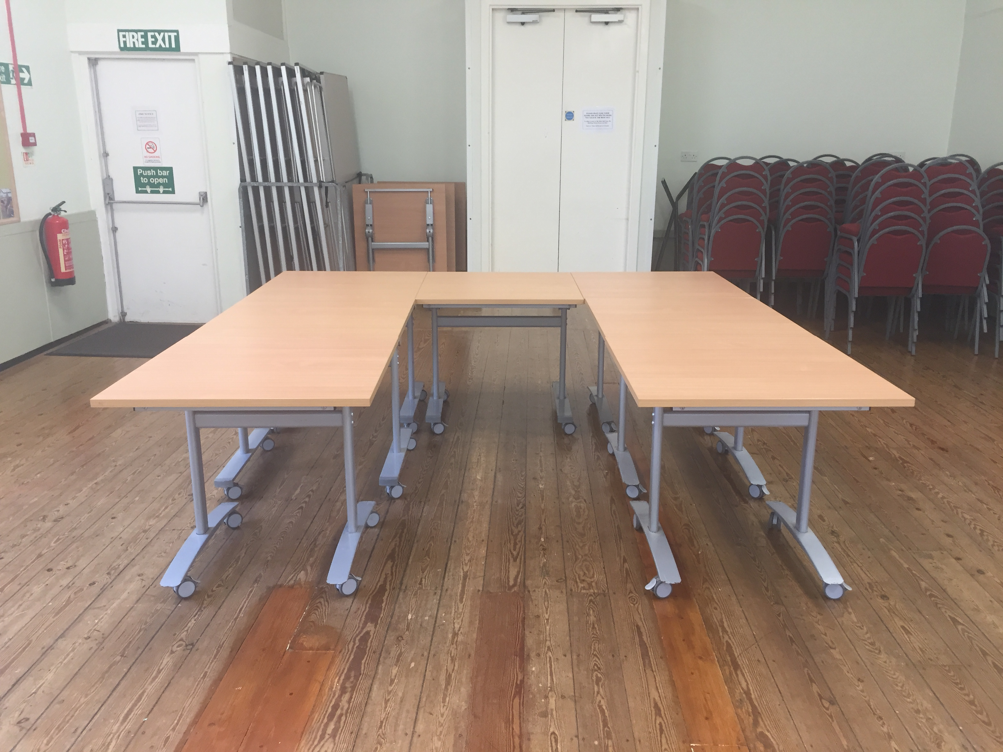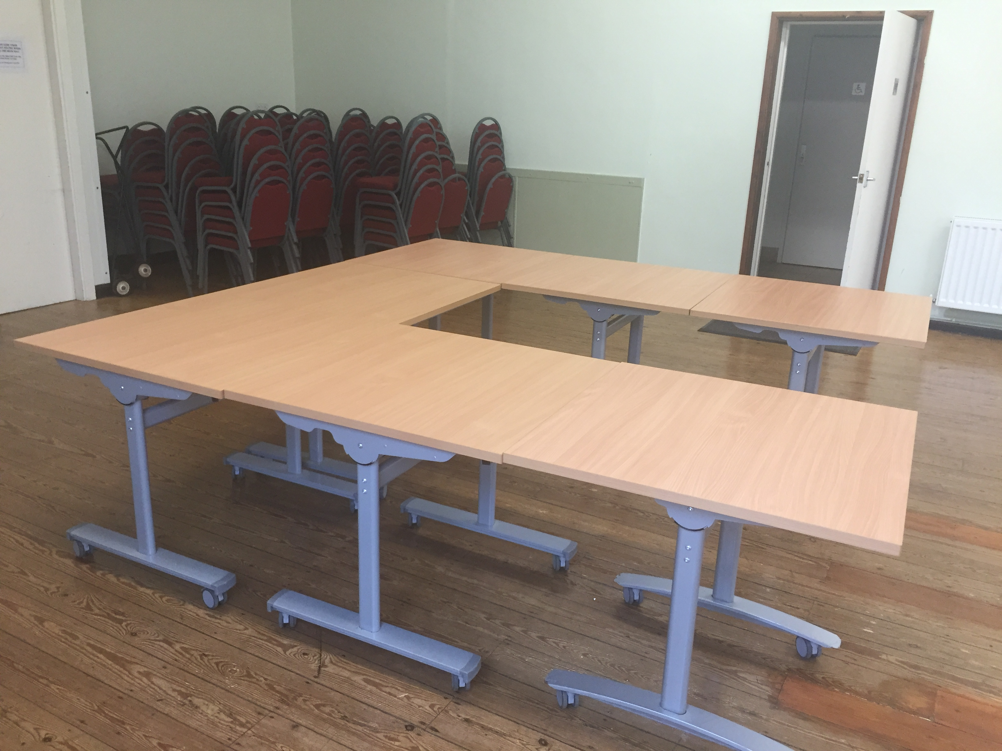

SC8:
You are requested to keep a record of the date and time the activity started and the name and contact telephone number or email of all those who attend your event (or at least one member of any group of up to 6 people or 2 households who attend together). This can be done either by operating an advance booking system which collects these details, or by asking everyone who attends to use the NHS QR poster at the hall entrance to register their attendance and by keeping a record of any who do not register using their smartphone app and the hall’s NHS QR poster or your own NHS QR poster.

SC9:
You are obliged to dispose of all rubbish created during your hire, including tissues and cleaning cloths, in the rubbish bags provided and placing in the Grey Refuse Bins outside the rear of the hall. All other rubbish should be taken away with you when you leave the hall

SC10:
Users are encouraged to bring their own drinks and food. If food or drink is being served or made on a DIY basis (as distinct to a water bottle used during exercise) it should if possible be consumed while seated.

SC11:
We will have the right to close the hall if there are safety concerns relating to COVID-19, for example, if someone who has attended the hall develops symptoms and thorough cleansing is required or if it is reported that the Special Hiring Conditions above are not being complied with, whether by you or by other hirers, or in the event that public buildings are asked or required to close again. If this is necessary, we will do our best to inform you promptly and you will not be charged for this hire.

SC12:
In the event of someone becoming unwell with suspected Covid-19 symptoms while at the hall you should remove them to the Designated Safe Area which is the Old Reading Room. Provide tissues and a bin or plastic bag, and a bowl of warm soapy water for handwashing. Ask others in your group to provide contact details if you do not have them and then leave the premises, observing the usual hand sanitising precautions, and advise them to launder their clothes when they arrive home.

Inform Lynn Allum, Booking Clerk on 07837 953266 OR Lynne Mahon, Chairman Management Committee on 07941 116240.
*As the Designated Safe Area the Old Reading Room is unavailable for use by hirers.

SC13:

All those attending your activity must wear a face covering unless an exemption or other government guidance applies to the activity (eg dancing, taking exercise). A face covering is not required when people are eating or drinking but they should be seated. All those attending your activity must wear a face covering when moving around the hall or using confined areas such as toilets and corridors, for the safety of others.

SC14:
Other special points as appropriate.

Where a sports, exercise or performing arts activity takes place:
(You will organise your activity in accordance with guidance issued by the relevant governing body for your sport or activity).

If equipment is stored in the hall you will ensure that it is cleaned before use and before being stored in the hall.

Signed : Date :

Updated October 2021

